**ONLINE SHOPPING**

**PAYMENT MODULE**

Virtual login screen is created for users to login based on their respective user ID’s.

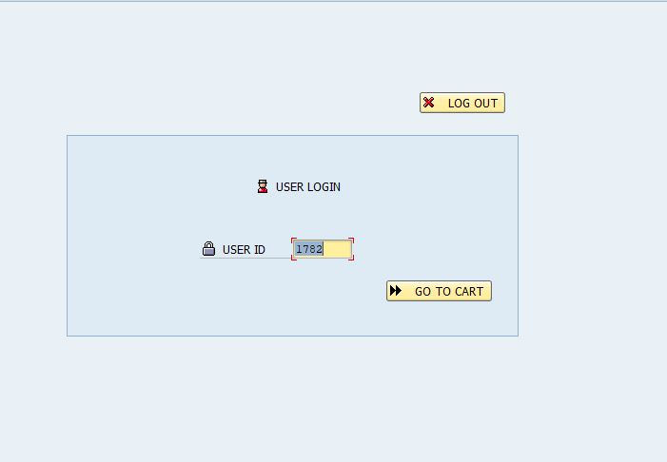

After entering the user ID, by clicking on the **GO TO CART** then the page is directed to **CART DETAILS**.

**2.**

**My cart** details will be displayed on the screen based on the respective user.

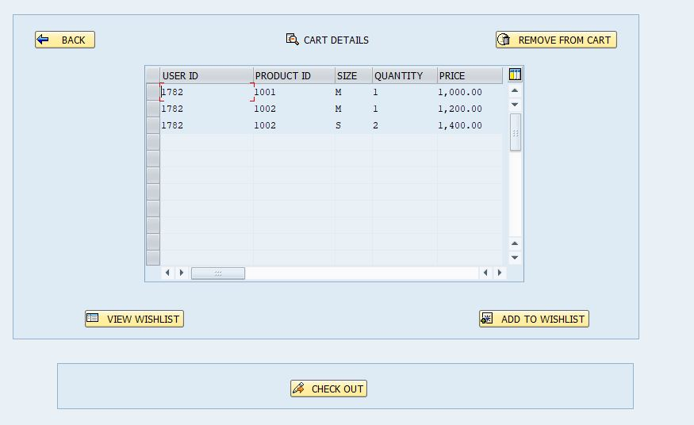

After opening the cart, If the user is not willing to place the order and if user wants to save some items for later then there is an option called ADD TO WISHLIST.

User selects the required product to save for later by choosing the above mentioned ADD TO WISHLIST. Then the product is removed from cart details and added to the My Wishlist.

If the user wants to remove the product from cart permanently the he can remove the product by selecting the product and clicking on the REMOVE FROM CART.

**3.**

After adding the required product to the My Wishlist, If the user wants to see the product which was added to My Wishlist there is an option called VIEW WISHLIST.

By clicking on the **VIEW WISHLIST** user can see the products which are saved for later.

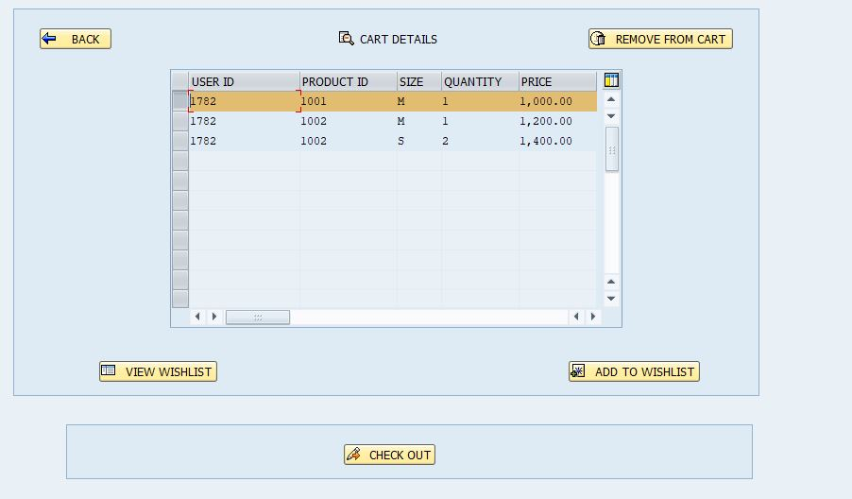

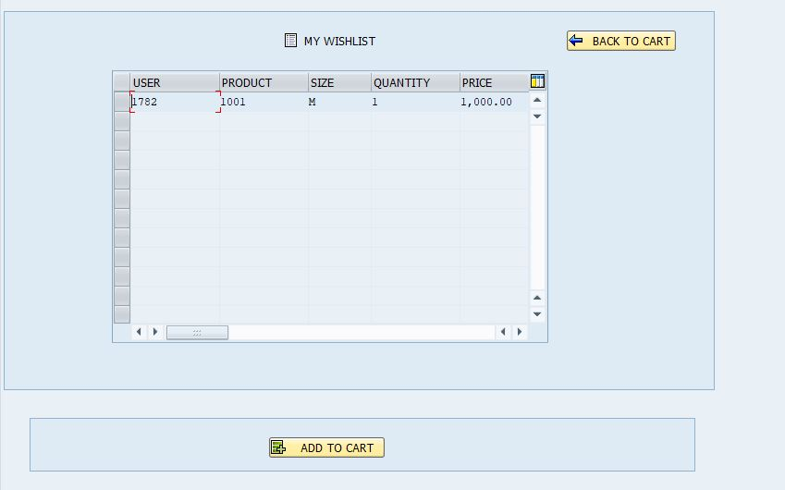

**4.**

After adding to the My Wishlist and viewing the products, If the user wants to add the product back into the CART the there is an option called **ADD TO CART**.

After selecting the product which user wants to add to cart from the Wishlist and clicking on the **ADD TO CART** then the product is added to the **CART DETAILS** and by clicking on the **BACK TO CART** user will redirected to the **CART DETAILS** screen.

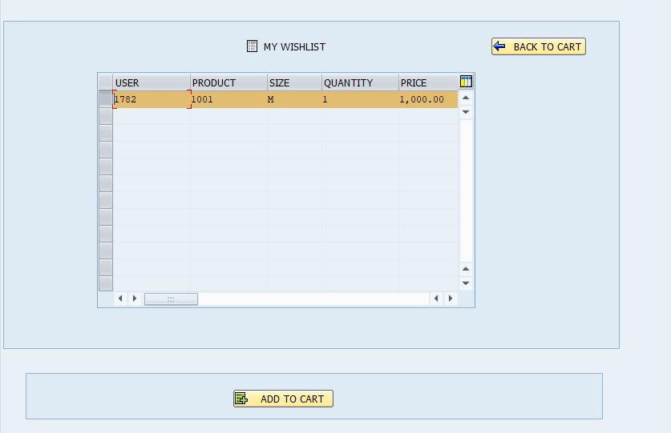

**5.**

Once user has decided the products which he want to order then he will be able to check out the products which he wants to order by clicking on the option **CHECKOUT.**

Then the page is redirected to the order details screen which was confirming regarding the order.

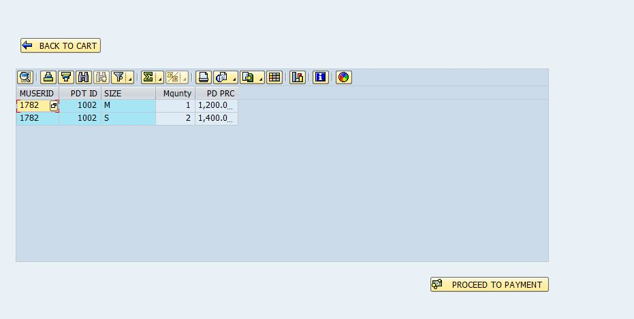

After displaying the order details, user can also go to the cart page by clicking on the **BACK TO CART** option.

Once the user had decided then he can proceed for the payment by clicking on the **PROCEED TO PAYMENT** option. Then the page is redirected to the **MODE OF** **PAYMENTS** screen.

**6.**

If the cart is empty and when you clicked on the CHECK OUT option, then there is pop-up is generated displaying message YOUR CART IS EMPTY.

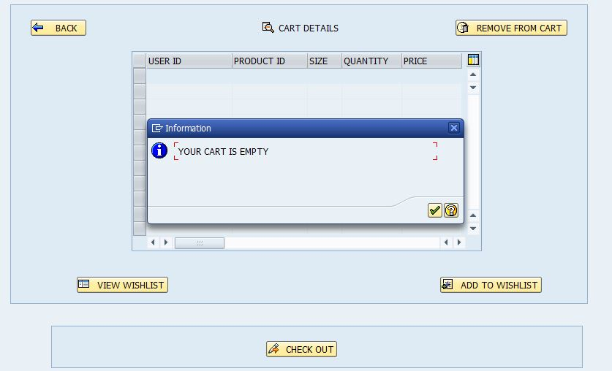

So, if the user wants to proceed to checkout card should not be empty. After user has added products to cart and proceed to checkout then **MODE OF PAYMENTS SCREEN** is displayed.

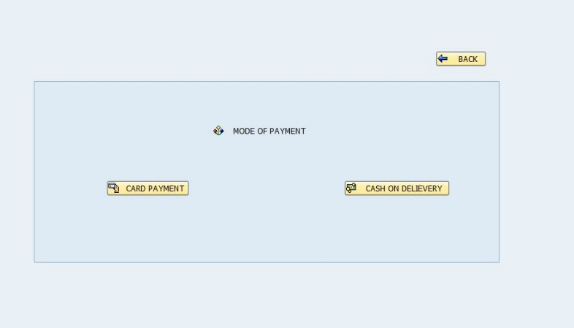

**7.**

**OPTION-1: CARD PAYMENT**

If user wants to pay online then user need to select card payment option. After selecting **Card Payment**, the user is redirected to next screen to enter card details.

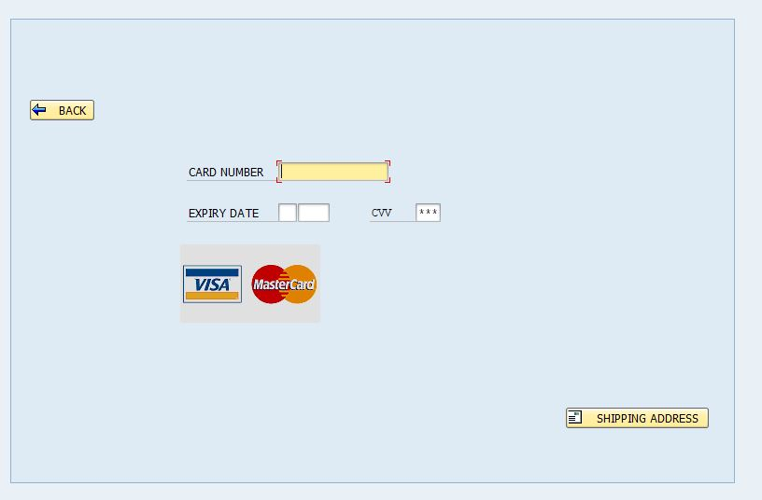

User needs to enter the card number, expiry month and year, and CVV.

CASE-1: If card number is invalid then a pop-up screen is generated stating INVALID CARD NUMBER.

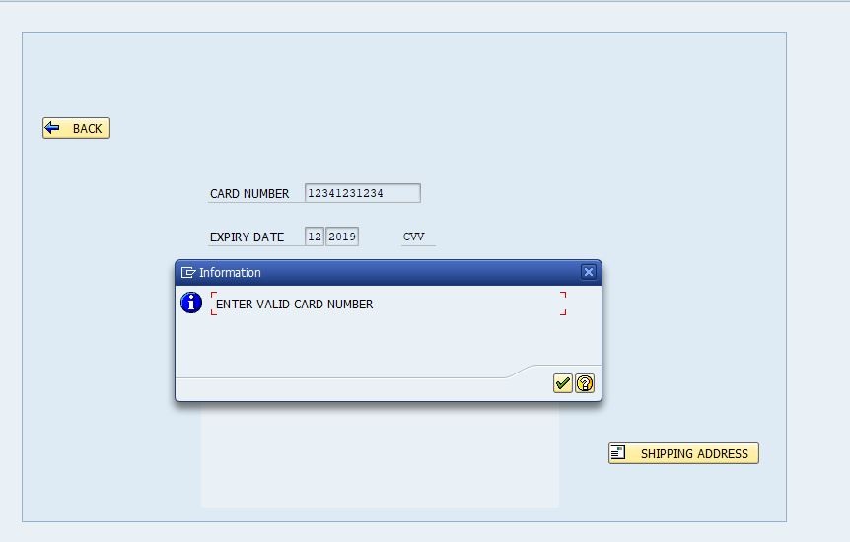

**CASE-2:** If expiry date is invalid, then a pop-up screen is generated stating INVALID EXPIRY DATE.

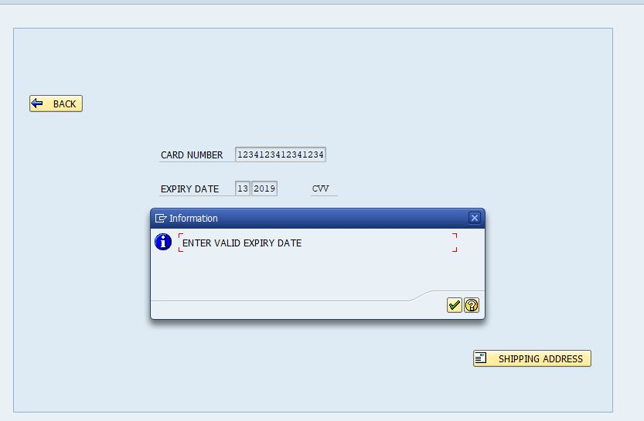

In this if either expiry month is invalid or if the expiry year is invalid then this pop-up is generated. As **CVV** is confidential it is graded out with ‘*’, So user need to careful while entering the **CVV.**

After entering the card details and expiry month and year and CVV user need to give the shipping address where the product needs to be delivered, So, user need to select the shipping address icon to enter the address details.

**OPTION-2: CASH ON DELIEVERY**

At MODE OF PAYMENT user needs to select the cash on delivery for COD, Where user pays money of the order at the time of delivery.

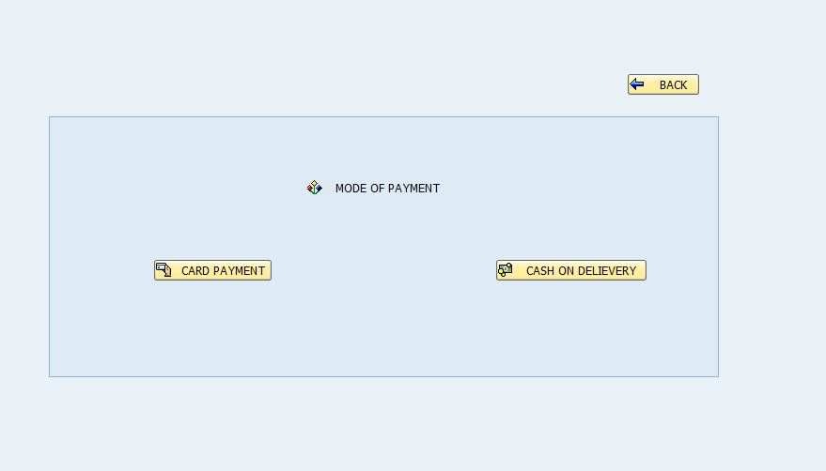

After selecting the COD option user needs to fill the contact details and shipped address details where the products need to be delivered and need to be contacted.

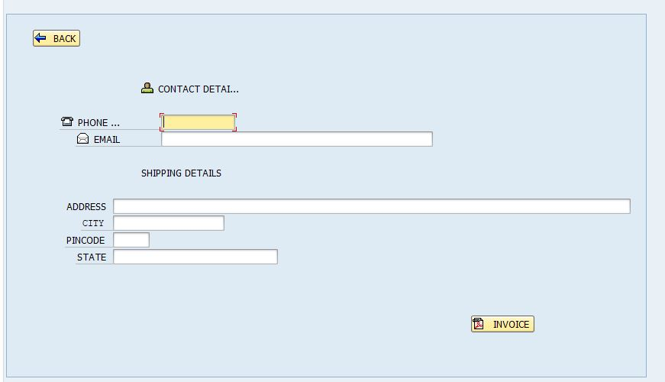

After filling the required details user needs to press the invoice button so that invoice pdf is generated.

**8.**

**Shipping Details:**



User need to enter the contact details like phone number and email ID and followed by shipping details which includes **Address, City, Pin-code and State.**

After entering the shipping details user needs to select the invoice option for getting his invoice pdf

**9. Invoice PDF**

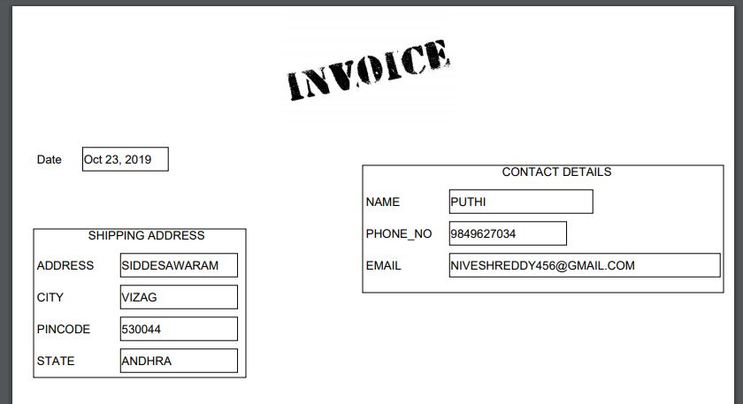

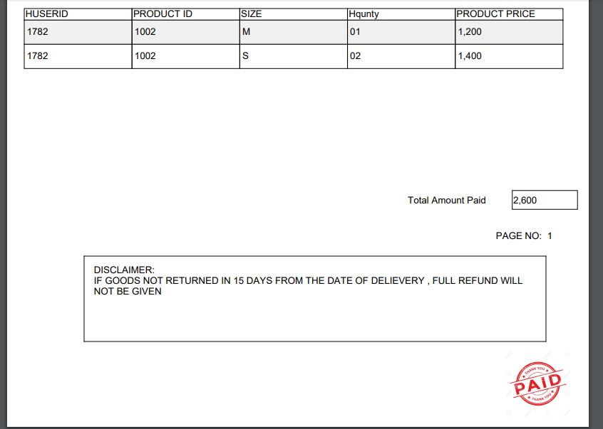

.

**TABLES USED IN PAYMENT MODULE.**

1. CART TABLE.

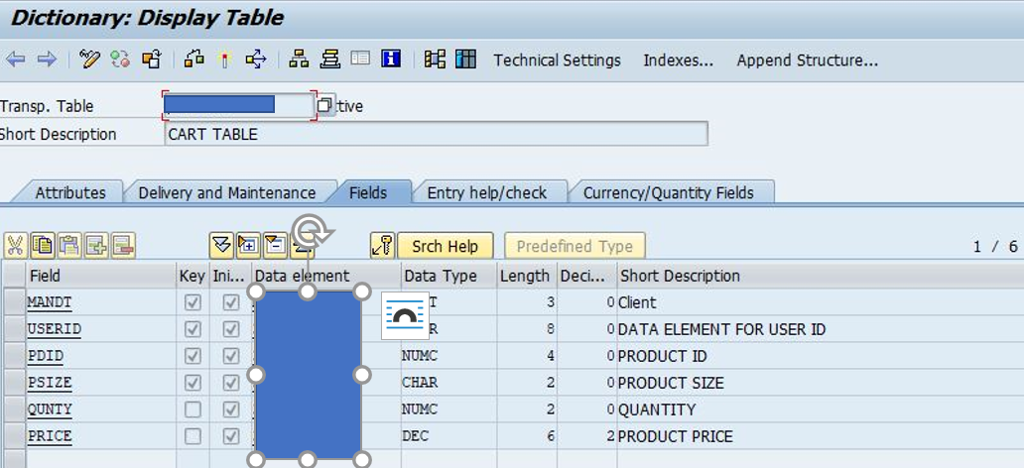

1. WISHLIST TABLE.

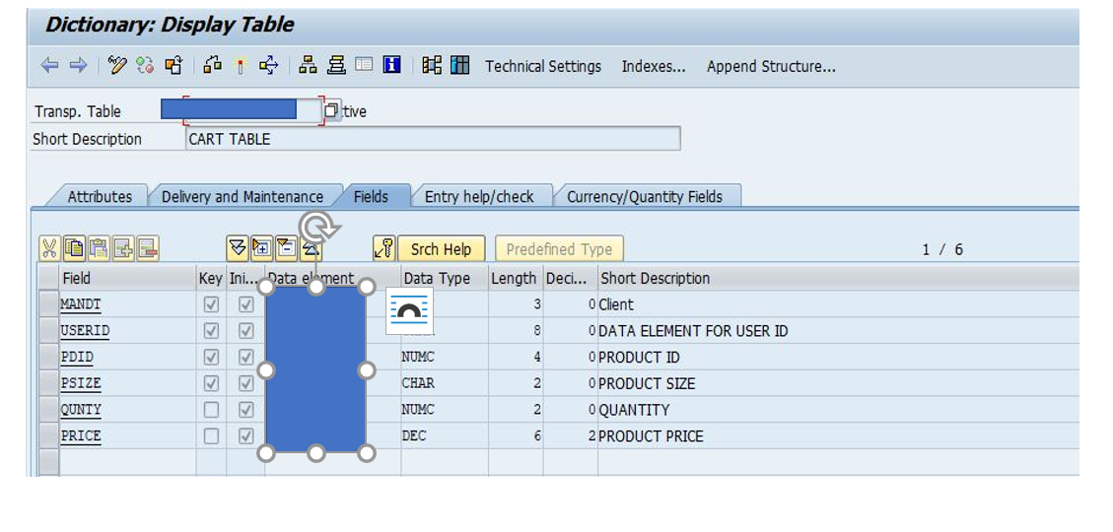

1. ORDER TABLE.

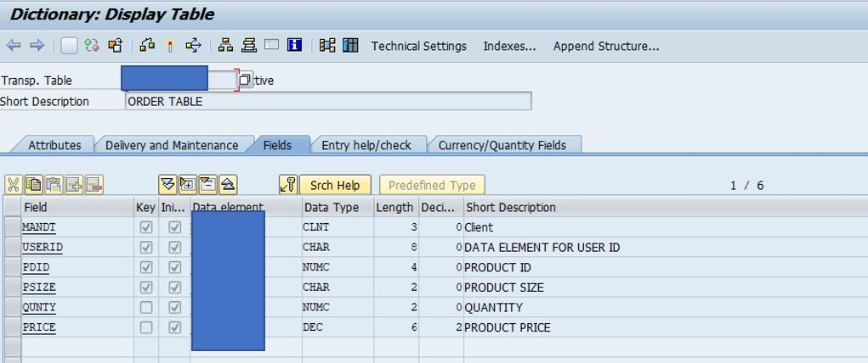

1. ORDER HISTORY TABLE.

